- PURPOSE:
This document defines the procedure required to program in-system-programmable Digi Me Ethernet device via the Digi Device Discovery application.

- SCOPE:
This document is limited to the programming of in-system programmable Digi Me Ethernet devices using an Ethernet cross over cable and the Digi Device Discovery application on the PC.

- FILES TO BE USED:
  - Digi Me Ethernet Programming file:
    - *.bin (dependent upon project; MNX, DXM, etc.)

- EQUIPMENT REQUIRED
  - A PC with an available ethernet port.
  - Ethernet Cross Over cable.
  - Target Control board.

- INSTALLATION PROCEDURE:

  - Setup programming hardware: Connect an Ethernet cross over cable from the PC to the Ethernet connector on the unit to be programmed.

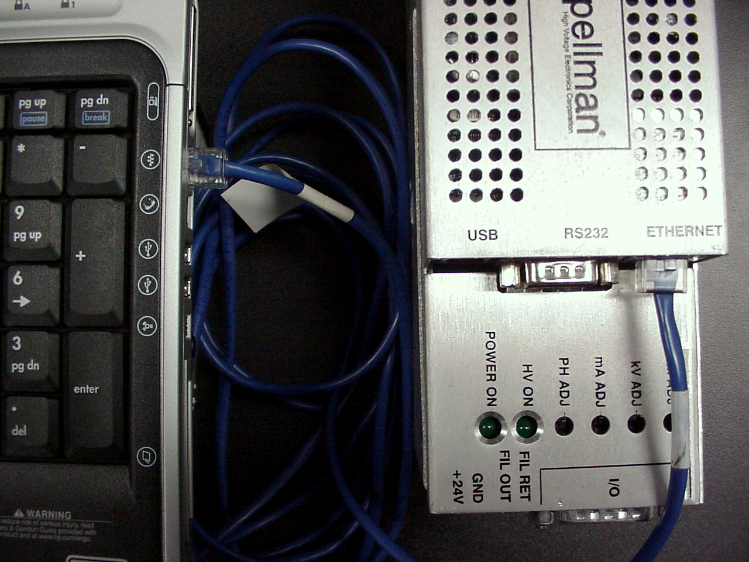

  - Turn power on unit. The green and yellow lights on the units Ethernet connector should blink. It takes the Digi Me Ethernet device approximately 60 seconds to boot. When the device has completed booting the yellow light should be on and the green light should blink.

  - On the Desk Top screen of the PC double click on the dgdscvr.exe icon.
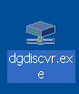

  - The Digi Device Discovery window should appear. If the application cannot communicate with the Digi Me Ethernet device it will display “no devices found”. When it can communicate, the screen will display the IP Address, MAC address, Name, and Device.

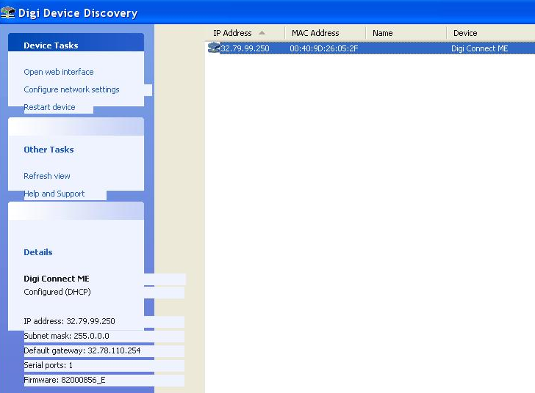

Device Found

  - The MAC Address should be the same as the MAC Address on the Digi Me on the board. In this case the MAC Address is 00409D:26052F which agrees with MAC Address on the Digi Device Discovery screen, 00:40:9D:26:05:2F. If not, call engineering.

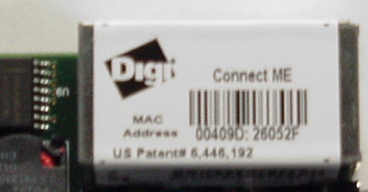

  - If no device was found make sure that the Ethernet cables are properly connected . If so, then call engineering.

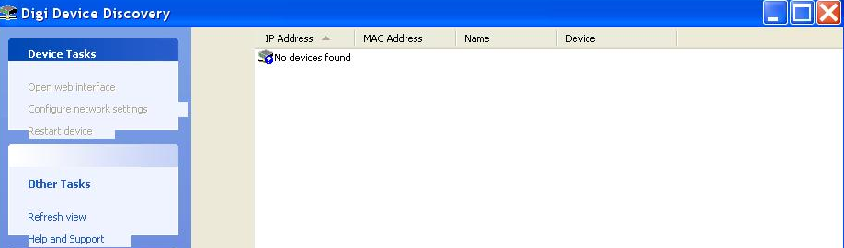

No Devices Found

  - If no IP Address appears on the screen then follow these steps, paragraphs 5.7.1 thru 5.7.11.

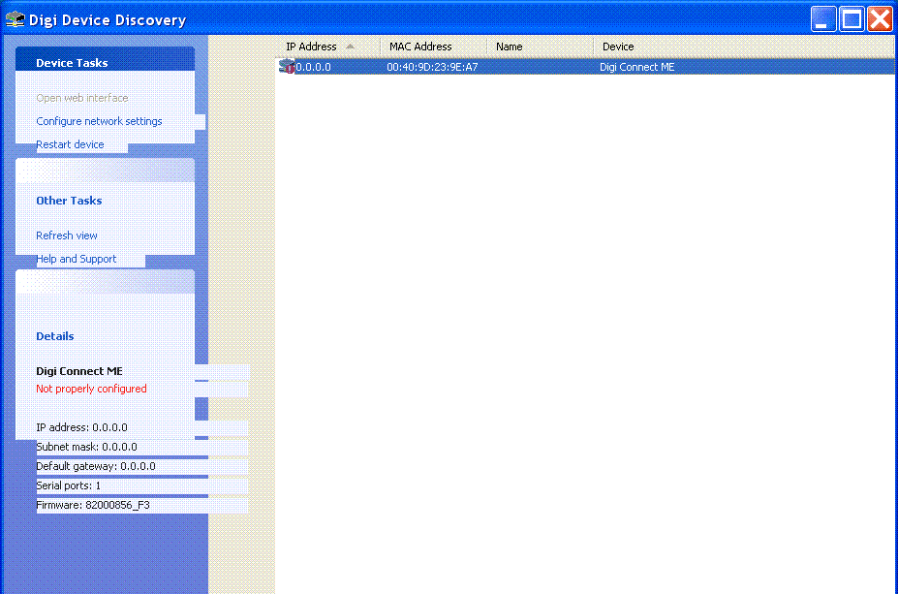

    - Right click on the main line in the screen where the IP Address, MAC Address, Name and Device appear. A menu will appear, select Configure network settings.

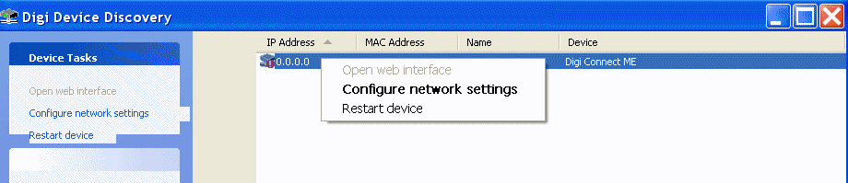

    - After Configure network settings is selected the following screen will appear .

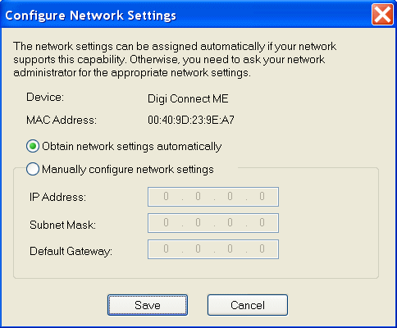

    - Select Manually configure network settings on the screen and enter the IP Address, Subnet Mask, and Default Gateway as it appears below. Then click on Save.

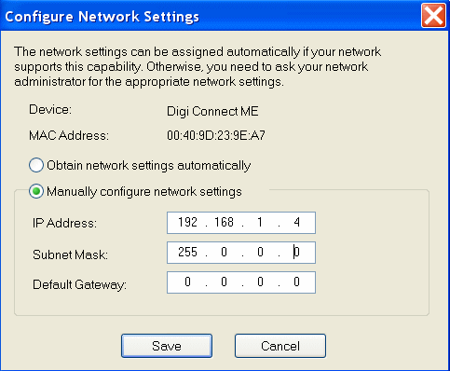

    - The following screen will appear where Not Properly Configured will appear under Digi Connect Me in the lower left part of the screen.

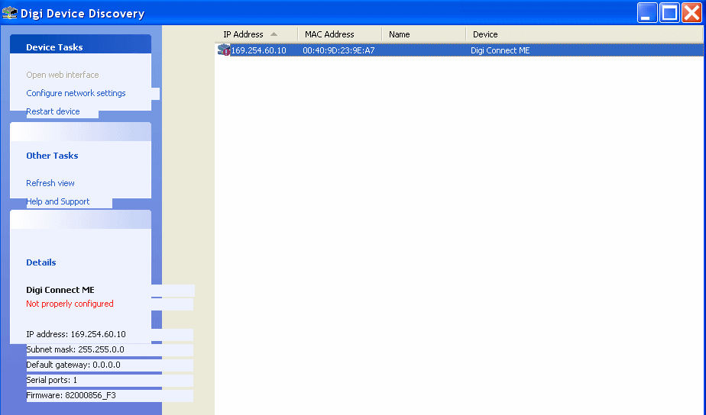

    - Right click on the main line in the screen where the IP Address, MAC Address, Name and Device appear. A menu will appear, select Configure network settings.

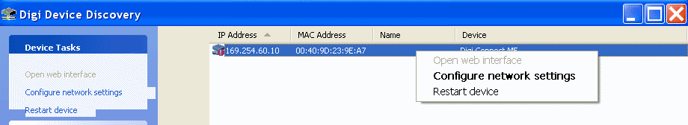

    - After Configure network settings is selected the following screen will appear.

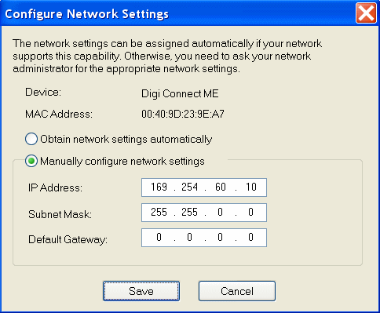

    - Enter the IP Address, Subnet Mask, and Default Gateway as it appears below. Then click on Save.

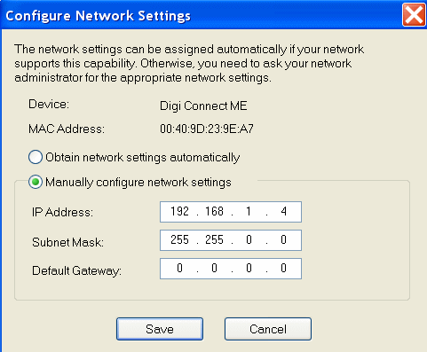

    - The following screen will appear, click OK.

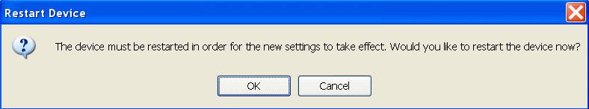

    - The following screen will appear. Wait for it to complete the reboot progression.

WARNING: DO NOT turn OFF or disturb the power during this process.

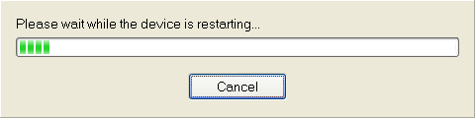

    - The following screen should appear with the appropriate IP Address and MAC Address. There should be no error messages appearing on the screen.

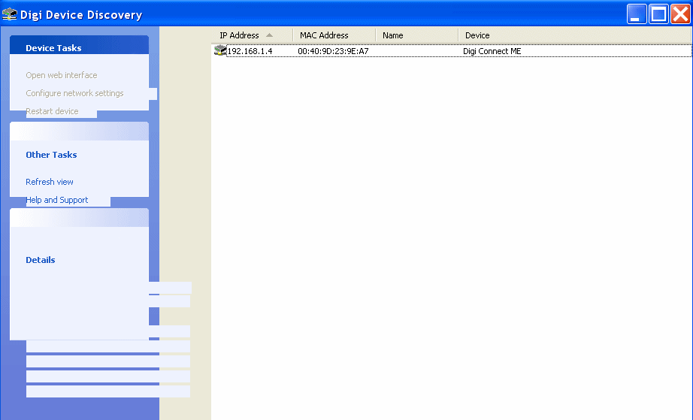

    - The IP Address is now set.

  - Double click on the row displaying the IP Address and MAC Address, a start up screen will appear. On newer manufactured Digi Me Ethernet devices a log in screen may come up first where a name (root) and password (dbps) needs to be entered and click the login button. Then the Digi Me Configuration and Management screen should appear.

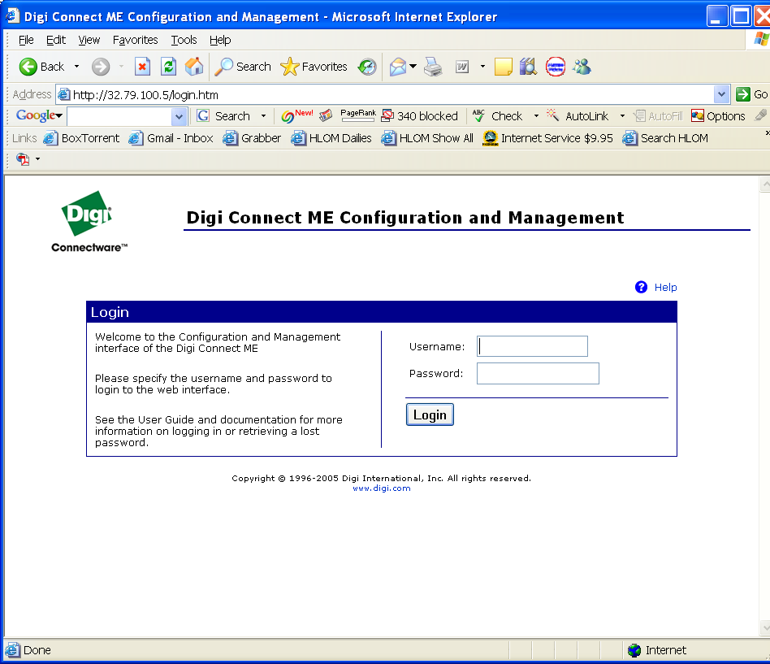

Log In Screen (New Devices)

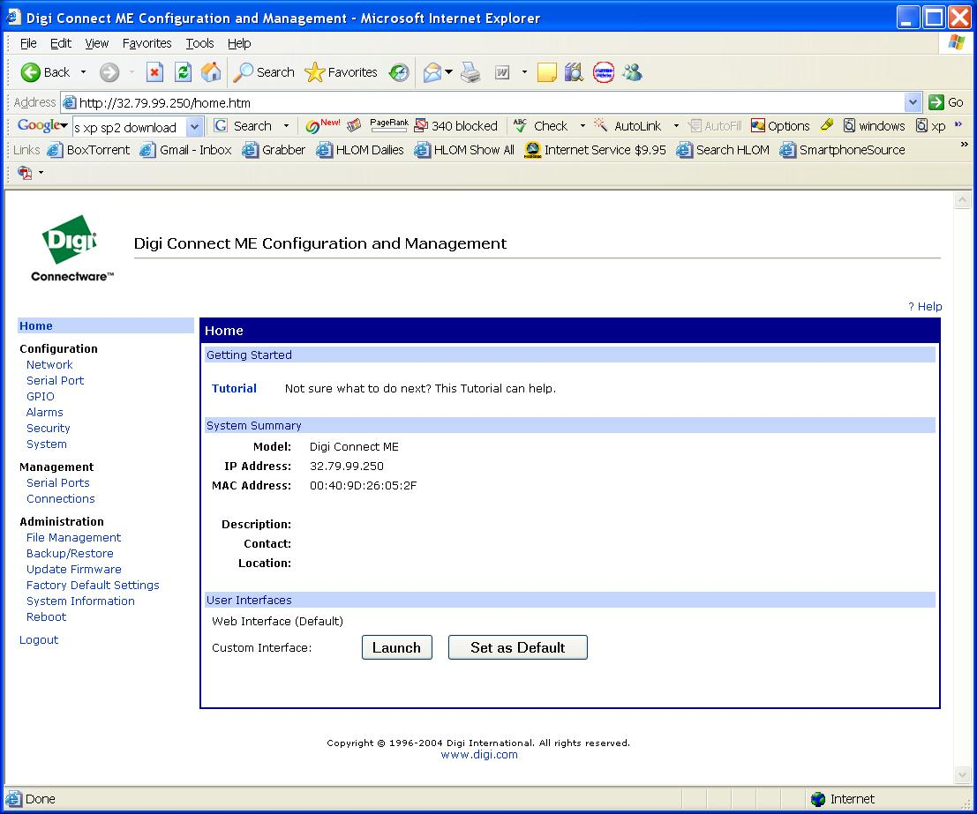

Digi Me Configuration and Management Screen

  - The Digi Me Configuration and Management screen should be seen. On the left hand side of the screen under Administration, click on Update Firmware. Using the Browse button to navigate to the directory where the firmware *.bin is located and select it.

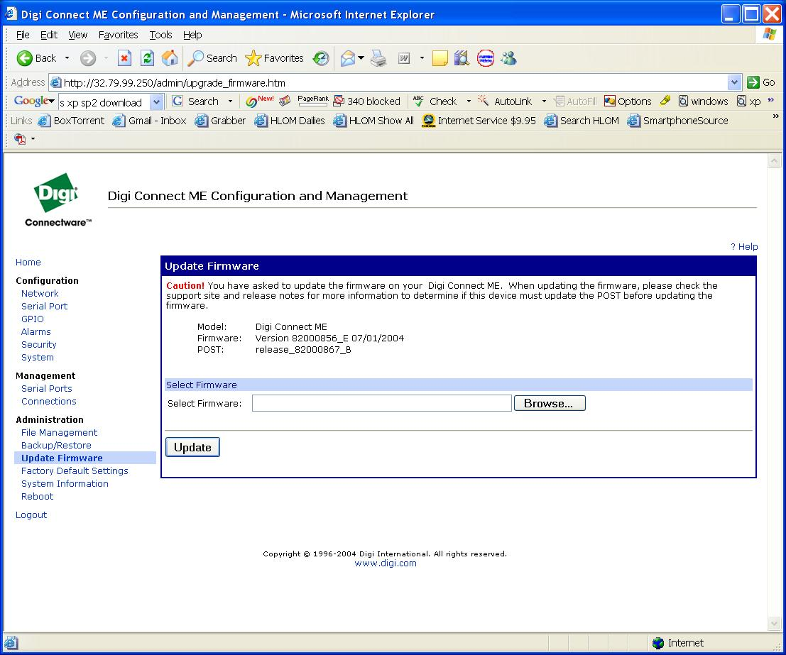

  - Click on the Update button.

WARNING: DO NOT turn OFF or disturb the power during this process.

  - Wait approximately 60 seconds, the yellow light should be on and the green light should be blinking. If not, DO NOT turn the power off and call engineering.

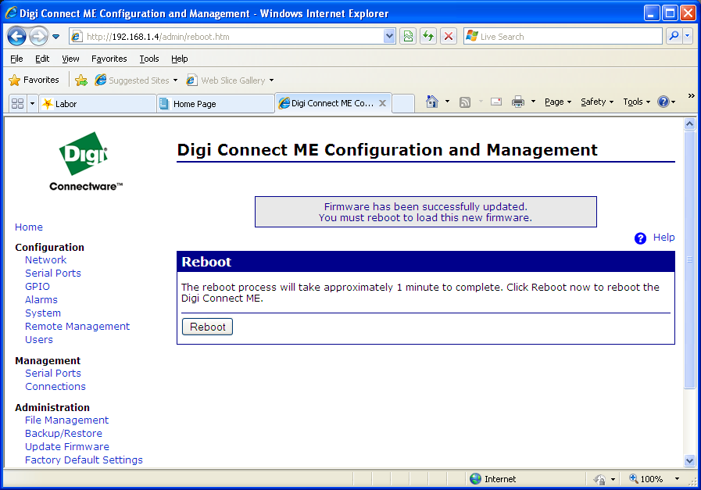

  - Click on the Reboot button.
  - The reboot process may take upto 2 minutes.

WARNING: DO NOT turn OFF or disturb the power during this process.

  - If the process is successful, the screen will refresh to a Spellman Splash Screen (Shows Picture of model and Spellman Logo).
  - If the screen does not refresh to the Spellman Splash Screen, DO NOT turn power off and contact Engineering.
  - The unit can be powered off.

End of document

